TheCouchPotato.com: An E-commerce Platform for Comfort Items

Christopher Markel

CST-451 Capstone Project Proposal

Grand Canyon University

Instructor: Professor Amr Elchouemi

Revision: 1

Date: 8/20/23

**ABSTRACT**

This project proposal outlines the development plan for the CST-451 Capstone Project at Grand Canyon University, supervised by Professor Amr Elchouemi. The primary objective is to create thecouchpotato.com, an innovative online platform dedicated to individuals seeking comfort and relaxation. The platform will feature a curated selection of products such as blankets, loungewear, snacks, and other comfort items, aiming to enhance the user's relaxation experience. By integrating user reviews, personalized recommendations, and a seamless shopping experience, the project seeks to establish a niche in the e-commerce market for comfort-centric products. As the project progresses, this abstract will be updated to reflect the milestones achieved, challenges encountered, and the broader impact of the platform in the realm of online shopping.

|  |
| --- |
| History and Signoff Sheet |

**Change Record**

|  |  |  |
| --- | --- | --- |
| **Date** | **Author** | **Revision Notes** |
| 8/20/2023 | Chris Markel | Initial draft for review/discussion |
|  |  |  |
|  |  |  |

|  |
| --- |
| **Overall Instructor Feedback/Comments** |

|  |
| --- |
| **Overall Instructor Feedback/Comments** |

**Integrated Instructor Feedback into Project Documentation**

☐ Yes ☐ No

**Project Approval**

☐ Professor Amr Elchouemi

**TABLE OF CONTENTS**

**Project Overview and Project Objectives 4**

**Project Scope 5**

**Project Success Measures 6**

**Project High-Level Solution 7**

**Project Controls 8**

**Project Cost and Schedule 10**

**Appendix A – References 11**

**Appendix B – Copyright Compliance 12**

**Project Overview and Project Objectives**

**State the Problem and Background**

Problem Statement:

In today's fast-paced digital age, the convenience of online shopping has become an integral part of our daily lives. E-commerce platforms have proliferated, offering a wide range of products to cater to diverse consumer needs. Yet, despite the vast array of available products, there remains a noticeable gap in the market: a dedicated platform for comfort items.

Background:

The evolution of e-commerce has transformed the way consumers shop. With just a few clicks, one can order anything from electronics to groceries. This convenience has led to a surge in online shopping, with many niche markets emerging to cater to specific consumer preferences. One such niche that has seen a surge in demand, especially in recent times, is comfort items. These are products specifically designed to enhance relaxation and provide a sense of well-being, especially when people are spending more time at home.

However, while there are platforms that offer a small number of these products, there isn't a centralized platform dedicated exclusively to comfort items. Consumers looking for such products often have to sift through multiple sites, making the shopping experience fragmented and less enjoyable.

TheCouchPotato.com's Proposition:

Recognizing this gap, TheCouchPotato.com aspires to be the premier e-commerce platform dedicated solely to comfort items. From plush slippers that cradle your feet after a long day to soft throw blankets perfect for cozy movie nights, TheCouchPotato.com aims to curate a selection that prioritizes relaxation and comfort. By centralizing these products in one platform, we hope to simplify the shopping process for consumers and establish ourselves as the go-to destination for all things comfort.

**Christian Worldview**

The Christian Worldview (CWV) is a comprehensive perspective that sees the world through the lens of Christian faith, values, and principles. It is a framework that influences every aspect of a believer's life, including their approach to projects and business ventures. In the context of TheCouchPotato.com, the CWV plays a pivotal role in shaping the project's direction, objectives, and ethical considerations.

*Ethical Perspective*:

TheCouchPotato.com, in alignment with Christian ethics, is committed to honest business practices. This means transparent dealings with suppliers, ensuring that products are sourced ethically, and maintaining integrity in advertising and customer interactions.

The platform will prioritize the well-being of its customers, ensuring that the comfort items sold are of high quality and safe for use.

Reference: "The integrity of the upright guides them, but the unfaithful are destroyed by their duplicity." - Proverbs 11:3

*Spiritual Perspective:*

The project embodies the Christian value of providing comfort and solace to others. By offering comfort items, the platform indirectly supports the idea of rest, rejuvenation, and self-care, which can be seen as aligning with the biblical principle of Sabbath rest.

Reference: "Come to me, all you who are weary and burdened, and I will give you rest." - Matthew 11:28

*Legal Perspective:*

TheCouchPotato.com will operate within the legal frameworks of the regions it serves. This adherence to the law is not just a business requirement but also a Christian obligation.

Reference: "Let everyone be subject to the governing authorities, for there is no authority except that which God has established." - Romans 13:1

*Historical Perspective:*

The Christian tradition has a rich history of craftsmanship, with believers creating items that serve both functional and spiritual purposes. TheCouchPotato.com, in a way, continues this tradition by offering products that enhance the quality of life.

*Social Perspective:*

The platform will foster a sense of community among its users. It can host forums or blogs where users share their experiences with the products, offering support and advice to one another. This aligns with the Christian principle of fellowship and community.

Reference: "And let us consider how we may spur one another on toward love and good deeds, not giving up meeting together, as some are in the habit of doing, but encouraging one another." - Hebrews 10:24-25

*Approach Guided by Christian Worldview:*

The approach to TheCouchPotato.com, under the guidance of the Christian worldview, is holistic. It's not just about selling products but about enhancing the well-being of its users. The platform aims to be more than a commercial entity; it aspires to be a community that embodies Christian values of love, care, and integrity. Every decision, from product selection to customer service, is made with the teachings of Christ in mind, ensuring that the platform operates with a higher purpose and serves its community in the best way possible.

**Project Objectives**

*Develop a User-Friendly E-Commerce Platform:*

1. Purpose: To create an intuitive and seamless online shopping experience for users.
2. Details: The platform will prioritize ease of navigation, allowing users to quickly find and purchase their desired comfort items. Features such as advanced search filters, product reviews, and a responsive design for mobile and tablet users will be incorporated.

*Ensure Secure Transactions for Customers:*

1. Purpose: To build trust and confidence among our users when making online purchases.
2. Details: Implementing state-of-the-art encryption methods and secure payment gateways will be paramount. Additionally, the platform will adhere to global data protection regulations, ensuring that customer data is stored securely and is not misused.

*Offer a Diverse Range of Comfort Products:*

1. Purpose: To cater to a wide audience with varied comfort needs and preferences.
2. Details: The product catalog will include items ranging from soft furnishings like throw blankets and cushions to wearable comfort items like slippers and loungewear. Periodic market research will be conducted to stay updated with trending comfort products and to continuously expand the product range.

*Promote Sustainable and Ethically Sourced Products:*

1. Purpose: To align with modern consumer values and contribute positively to the environment and society.
2. Details: The platform will prioritize vendors and manufacturers who adhere to sustainable and ethical production methods. Products will be accompanied by details regarding their sourcing and manufacturing processes, allowing consumers to make informed choices. Additionally, partnerships with eco-friendly brands will be sought to further promote sustainability.

By achieving these objectives, TheCouchPotato.com aims to not only provide comfort to its users but also ensure that the comfort is sourced and delivered in an ethical and sustainable manner.

**Challenges**

*Ensuring a Seamless User Experience:*

1. Details: With the vast array of devices, browsers, and internet speeds, creating a universally smooth and responsive platform can be challenging. The platform needs to be optimized for various screen sizes, from mobile phones to desktop monitors. Additionally, ensuring that the website loads quickly and efficiently, even in areas with slower internet connections, is crucial.
2. Implications: A subpar user experience can deter potential customers, leading to decreased sales and a tarnished brand reputation.

*Sourcing Quality Products:*

1. Details: Identifying and partnering with reliable suppliers who consistently provide high-quality comfort products is a significant challenge. This involves rigorous quality checks, vetting suppliers, and establishing long-term relationships.
2. Implications: Offering substandard products can lead to customer dissatisfaction, returns, and negative reviews, which can harm the platform's credibility.

*Managing Inventory and Logistics:*

1. Details: Efficiently managing stock levels to ensure product availability while avoiding overstocking is a delicate balance. Additionally, establishing a reliable logistics and delivery system to ensure timely and safe delivery of products to customers is crucial.
2. Implications: Inventory mismanagement can lead to lost sales opportunities or increased holding costs. Delays or mishaps in delivery can result in customer dissatisfaction and increased return rates.

*Ensuring Data Security and Privacy:*

1. Details: With the increasing threats of cyber-attacks and data breaches, ensuring the platform's security is paramount. This involves implementing robust cybersecurity measures, regularly updating software, and adhering to global data protection regulations.
2. Implications: A data breach can lead to a loss of customer trust, legal repercussions, and significant financial losses. Ensuring data privacy is not just a technical requirement but also essential for maintaining brand integrity and customer loyalty.

Addressing these challenges requires a combination of strategic planning, continuous monitoring, and proactive problem-solving. By recognizing and preparing for these potential hurdles, TheCouchPotato.com aims to establish itself as a trusted and reliable e-commerce platform in the comfort product niche.

**Benefits and Opportunities**

*Tapping into a Niche Market with Potential for Growth:*

1. Details: The comfort product sector, though niche, has shown consistent demand, especially in the current era where home-based activities have seen a surge. By focusing on this specific market, TheCouchPotato.com can cater to a dedicated audience, ensuring a loyal customer base.
2. Implications: This specialization allows for targeted marketing strategies, curated product selections, and tailored user experiences. As the market continues to evolve, there's potential for introducing new product lines and expanding the platform's offerings, leading to increased revenue streams.

*Promoting a Lifestyle of Comfort and Relaxation:*

1. Details: In today's fast-paced world, there's a growing emphasis on self-care, relaxation, and mental well-being. By offering products that enhance comfort, TheCouchPotato.com not only sells items but also promotes a lifestyle that prioritizes personal well-being.
2. Implications: This approach can lead to a deeper emotional connection with customers. It positions the brand as not just a retailer but a partner in the customer's journey towards a more relaxed and comfortable lifestyle. This can foster brand loyalty and encourage repeat purchases.

*Building a Brand that Values Sustainability and Ethical Sourcing:*

1. Details: Modern consumers are increasingly conscious of the environmental and ethical implications of their purchases. By committing to sustainability and ethical sourcing, TheCouchPotato.com aligns itself with these values, setting it apart from competitors.
2. Implications: This commitment can attract a segment of consumers who prioritize eco-friendly and ethically produced products. It can also lead to partnerships with sustainable suppliers and brands, further enhancing the platform's product range. In the long run, this approach not only benefits the environment and society but also positions the brand as a responsible and forward-thinking entity in the market.

By capitalizing on these benefits and opportunities, TheCouchPotato.com has the potential to carve out a significant space in the e-commerce landscape, offering products that resonate with consumers' values and lifestyle choices.

***NOTE: If necessary, you may add subsections to those listed in order to match the requirements in the assignment description. Do not remove any top-level sections (those that are listed in the Table of Contents).***

**Project Scope**

TheCouchPotato.com: A Dedicated E-Commerce Platform for Comfort Items

*Comprehensive User Experience:*

1. Details: The platform will be designed with user-friendliness at its core. From intuitive navigation to detailed product descriptions, every aspect will be tailored to ensure that users can easily find and purchase their desired comfort items.
2. Implications: A seamless user experience can lead to increased user retention, higher conversion rates, and positive word-of-mouth recommendations.

*User Reviews and Feedback:*

1. Details: Customers will have the ability to leave reviews for products they've purchased, providing insights on quality, comfort, and overall satisfaction. This feature not only aids potential buyers in making informed decisions but also provides valuable feedback to the platform and suppliers.
2. Implications: User reviews can enhance trustworthiness and credibility. They can also guide inventory decisions, highlighting popular products or indicating areas for improvement.

*Personalized Product Recommendations:*

1. Details: Leveraging advanced algorithms, the platform will suggest products based on users' browsing history, past purchases, and popular trends. This ensures that users are presented with items that align with their preferences and needs.
2. Implications: Personalized recommendations can increase sales by encouraging users to explore more products and making their shopping experience more tailored and engaging.

*Secure Transactions:*

1. Details: Ensuring the security of users' data, especially financial information, is paramount. The platform will integrate trusted payment gateways and employ advanced encryption techniques to safeguard transactions.
2. Implications: A secure transaction environment can boost user confidence, leading to increased sales and repeat customers.

*Exclusions from the Scope:*

1. Digital Products: The platform will focus solely on tangible comfort items, excluding any form of digital goods or services.
2. Subscription Services: While users can create accounts and receive updates, there won't be any subscription-based services or recurring charges.
3. Third-party Advertisements: To maintain a clutter-free and dedicated shopping experience, the platform will not host third-party ads or promotional content.

By clearly defining the scope, TheCouchPotato.com ensures that all stakeholders have a shared understanding of the project's boundaries, objectives, and deliverables. This clarity will be instrumental in guiding development efforts and ensuring alignment with the platform's core mission.

Use the template to list all known stakeholders and contacts, if applicable, including self (for some projects self may be the only name listed)

|  |  |  |
| --- | --- | --- |
| Stakeholder Name | Role(s) | Responsibilities |
| Chris Markel | Project Manager | Overseeing the entire project, liaising with stakeholders, ensuring project objectives are met |
| Jeanette Markel | Lead QA Tester | Ensuring usability of platform meets the project objectives |

List the work breakdown required to satisfy the project objectives. Identify teams and other resources that may be required to successfully complete the project.

|  |  |  |  |  |  |  |  |  |  |  |
| --- | --- | --- | --- | --- | --- | --- | --- | --- | --- | --- |
| Work Breakdown Structure | | | | | | | | | | |
| ID | Task | Dependencies | Status | Effort Hours | Cost | Start Date | Planned Completion | Estimate to Completion | Actual Completion | Resource |
| 1 | Setup initial project infrastructure | None | Started | 10 | $0 | 8/14/2023 | 8/20/2023 | 1 week | 8/20/2023 | Chris Markel |
| 2 | Design UI/UX for the platform | Task 1 | Started | 10 | $0 | 8/14/2023 | 8/20/2023 | 1 week | 8/20/2023 | Chris Markel |
| 3 | Conduct market research for product sourcing | None | Upcoming | 15 | $0 | 8/21/2023 | 8/23/2023 | 3 days | - | Chris Markel |
| 4 | Define user requirements and potential challenges | Task 3 | Upcoming | 10 | $0 | 8/24/2023 | 8/26/2023 | 3 days | - | Chris Markel |
| 5 | Draft architectural plan for platform | Task 2 | Upcoming | 20 | $0 | 8/28/2023 | 8/30/2023 | 3 days | - | Chris Markel |
| 6 | Develop core functionalities (product listing, user registration, payment gateways) | Task 5 | Upcoming | 30 | $0 | 9/04/2023 | 9/06/2023 | 3 days | - | Chris Markel |
| 7 | Implement additional features (user reviews, product recommendations) | Task 6 | Upcoming | 25 | $0 | 9/07/2023 | 9/09/2023 | 3 days | - | Chris Markel |
| 8 | Comprehensive testing and quality assurance | Task 6 & 7 | Upcoming | 15 | $0 | 9/07/2023 | 9/10/2023 | 4 days | - | Chris Markel |
| 9 | Final review and submission | All tasks | Upcoming | 5 | $0 | 9/10/2023 | 9/10/2023 | 1 day | - | Chris Markel |

**Project Success Measures**

1. Describe what measures will be used to calculate project success.

The success of TheCouchPotato.com will be gauged through several key metrics. User engagement will be monitored via Monthly Active Users (MAU) with a goal to consistently grow and maintain a retention rate above 60%. Financial health will be assessed through monthly sales volume, targeting a 10% month-over-month growth. Customer satisfaction will be pivotal, aiming for a Net Promoter Score (NPS) above 70 and a Customer Satisfaction Score (CSAT) above 85%. Operational efficiency will be tracked by reducing order fulfillment time by 15% and maintaining a swift inventory turnover. On the digital front, website performance will be optimized to achieve a load time under 3 seconds and reduce bounce rates, while also enhancing brand awareness through increased social media engagement and positive online reviews. By aligning with these metrics, TheCouchPotato.com aspires to establish itself as a premier platform for comfort items.

1. Use the template to list the project completion criteria.

|  |
| --- |
| Project Completion Criteria |
| 1. Successful deployment of the e-commerce platform. |
| 1. At least 50 products listed during launch. |
| 1. Positive feedback from initial users regarding user experience. |
| 1. Mobile-responsive design. |
| 1. Integration of a user review system. |
| 1. Secure and diverse payment options. |
| 1. Efficient customer support system. |
| 1. Return and refund policy in place. |
| 1. User account creation and management. |
| 1. Regular updates and maintenance schedule. |

3. Use the template to list the project assumptions and constraints, if applicable. An assumption is an educated guess that a likely condition or circumstance is presumed to be true. A constraint is a limiting condition or circumstance that defines the project boundaries. Assumptions allow the project to succeed. Constraints restrict or limit the project execution.

|  |  |  |  |  |  |
| --- | --- | --- | --- | --- | --- |
| Assumptions and Constraints | | | | | |
| ID | Description | Comments | Type | Status | Date Entered |
| 1 | Users will have access to the internet | Essential for accessing the platform | Assumption | Active | 8/20/2023 |
| 2 | Limited initial budget | May restrict aggressive marketing strategies | Constraint | Active | 8/20/2023 |
| 3 | Users are familiar with e-commerce platforms | Reduces the learning curve for users | Assumption | Active | 8/20/2023 |
| 4 | Platform will be primarily accessed via mobile devices | Mobile-first design approach | Assumption | Active | 8/20/2023 |
| 5 | Vendor partnerships will be established for product sourcing | Essential for product availability | Assumption | Active | 8/20/2023 |
| 6 | Platform development will be completed within the set timeline | Ensures timely launch | Constraint | Active | 8/20/2023 |
| 7 | Limited to specific geographic regions for shipping | May restrict global outreach | Constraint | Active | 8/20/2023 |
| 8 | Users value sustainable and ethically sourced products | Aligns with brand values | Assumption | Active | 8/20/2023 |
| 9 | Platform will need regular updates post-launch | Ensures platform remains up-to-date | Assumption | Active | 8/20/2023 |
| 10 | Limited customer support staff initially | May lead to longer response times | Constraint | Active | 8/20/2023 |

**Project High-Level Solution**

**Introduction**

The primary challenge addressed in this project is the fragmented market for comfort items. Consumers often find themselves browsing multiple platforms to find their desired comfort products, leading to a disjointed and time-consuming shopping experience. The objective of TheCouchPotato.com is to consolidate this market, offering a one-stop platform for all comfort items, from plush blankets to ergonomic furniture. The solution aims to provide a seamless user experience, intuitive navigation, and a comprehensive product range. Assumptions made include the consistent demand for comfort items and the willingness of consumers to switch to a more consolidated platform if it offers value.

**Solution**

The solution for TheCouchPotato.com is a combination of theoretical and technical implementations.

*Theoretical Framework:*

The platform operates on the principle of "Unified Comfort Shopping." This concept emphasizes the importance of a centralized marketplace for comfort items, ensuring consumers can find all their needs in one place. By understanding consumer behavior and preferences, the platform curates a product range that caters to diverse comfort needs.

*Technical Implementation:*

The website will be developed using a robust backend framework like Spring, ensuring scalability and security. The frontend will utilize ReactJS for a dynamic and responsive user interface. The platform's architecture will be modular, comprising components like User Management, Product Catalog, Order Processing, and Review & Ratings. Each component will have specific functionalities:

*User Management:* Handles user registration, login, and profile management.

*Product Catalog:* Manages product listings, categorization, and search functionalities.

*Order Processing:* Takes care of cart management, payment processing, and order tracking.

*Review & Ratings:* Allows users to rate products and leave reviews, aiding others in their purchase decisions.

The data input to the platform includes product details, user information, order details, and reviews. The output is the processed information displayed to the end-users, such as product listings, order confirmations, and user profiles.

For a visual representation, a UML diagram will detail the relationships between different components and data flow. Flowcharts will guide the user journey from landing on the platform to completing a purchase. Key code snippets, especially for critical functionalities like payment processing and user authentication, will be highlighted and explained in detail.

All external resources, such as third-party payment gateways or plugins, will be duly referenced, ensuring transparency and compliance.

In conclusion, TheCouchPotato.com's solution is a holistic approach to address the fragmented comfort item market. By offering a unified platform with a strong theoretical foundation and robust technical implementation, it aims to redefine the way consumers shop for comfort items.

*High-Level Architecture Diagram*

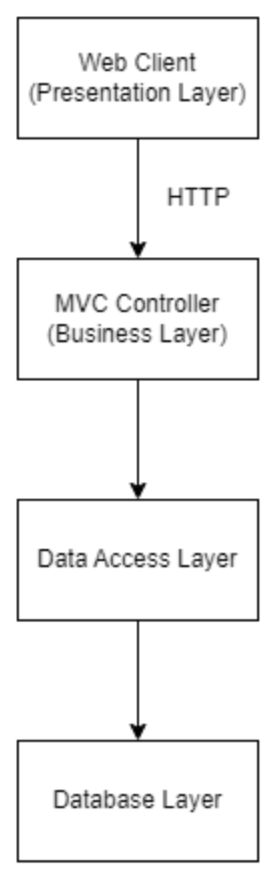

*Logical System Diagram*

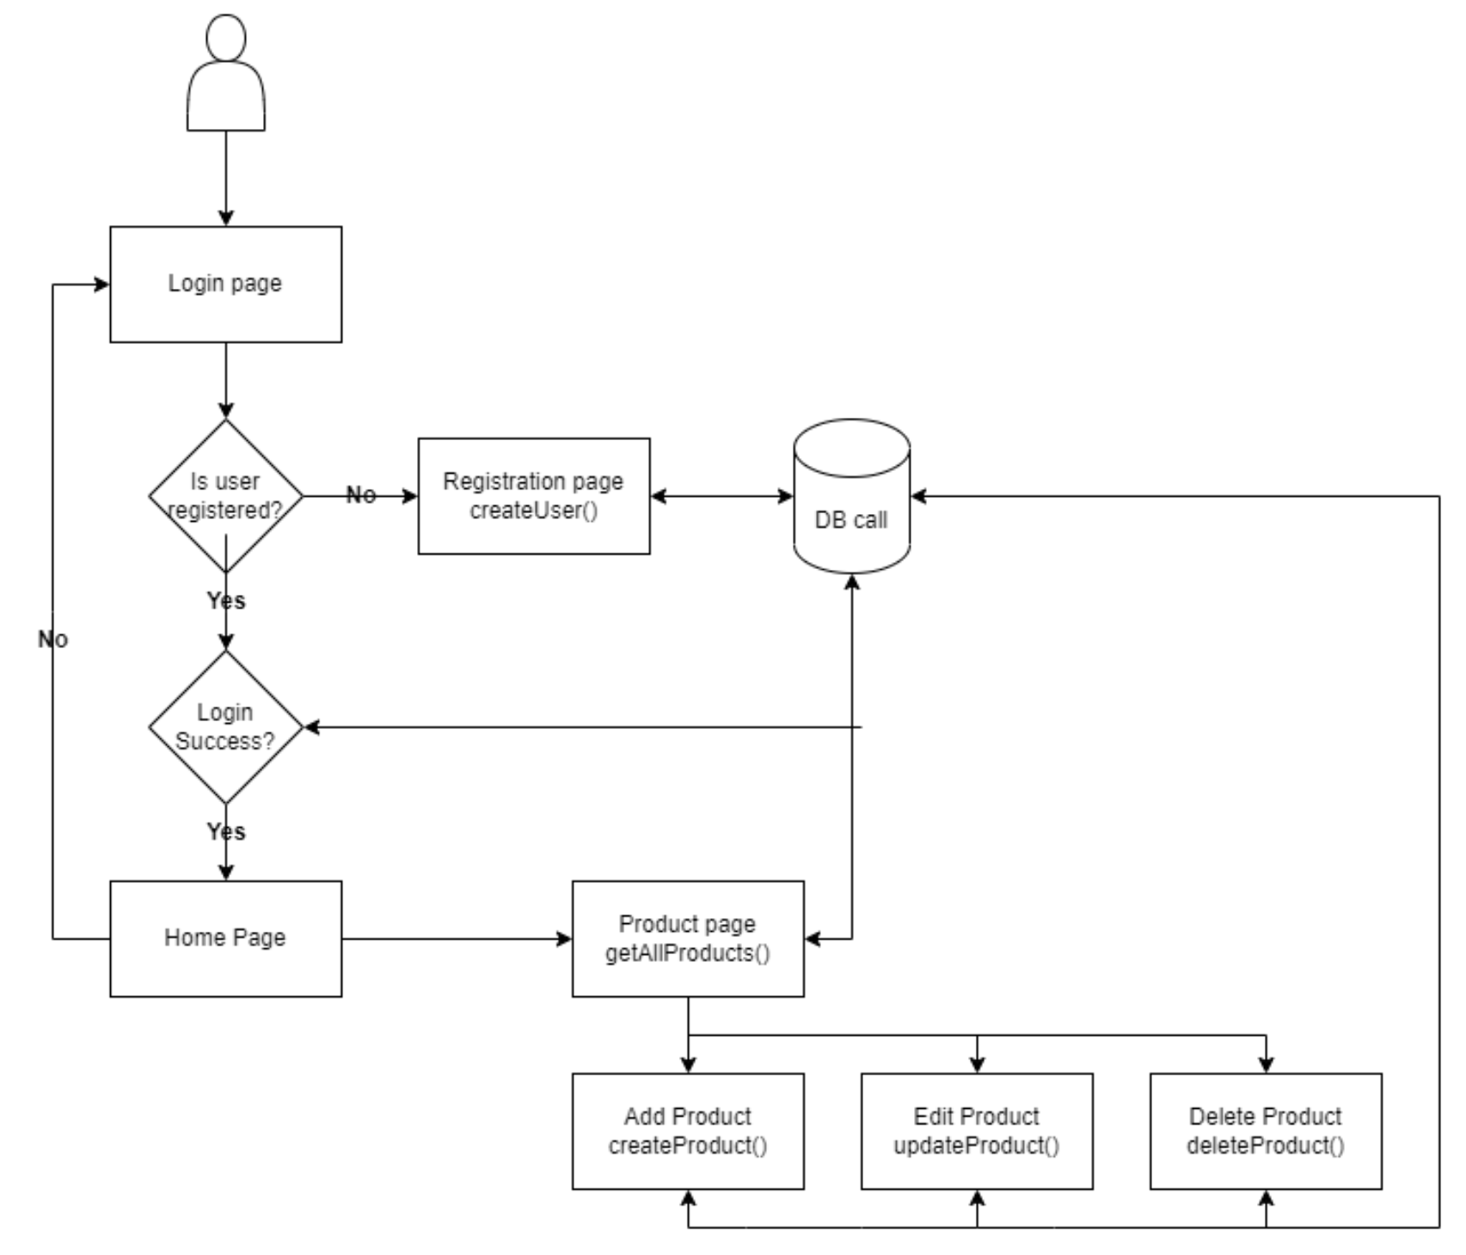

*Shopping Cart Logical System Diagram*

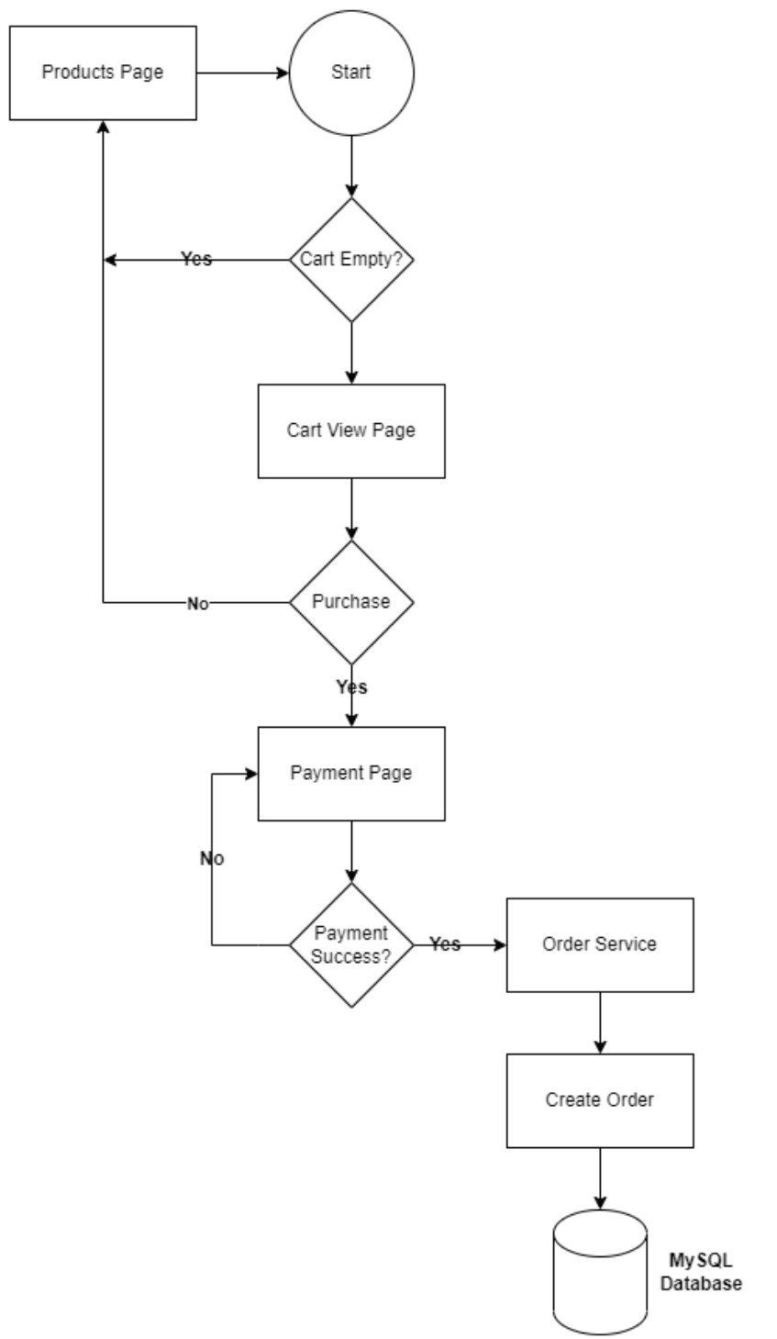

**Project Controls**

Use the template to define the risk and list the steps to prevent the risk from occurring or the steps to minimize the chances of it happening. The contingency plan describes alternative solutions to reduce the impact of the risk. An example of a contingency plan is to provide the customer a temporary web server if there are delays in delivery/completion. If the risk has already happened then provide an entry in the issue log.

|  |  |  |  |  |
| --- | --- | --- | --- | --- |
| Risk Management | | | | |
|  | **Risk Probability** | **Risk Impact** |  |  |
| **Event Risk** | **(high, medium, low)** | **Risk Mitigation** | **Contingency Plan** |
| What is the risk? | What is the probability? | What is the impact if the risk occurs? | What can be done to minimize the risk? | What can be done to minimize the impact of the risk? |
| Data breach | Medium | High | Implement robust security measures | Immediate notification to users, rectification, and offering credit monitoring services |
| Supply chain disruption | Low | Medium | Establish multiple vendor partnerships | Source alternative vendors or adjust product listings temporarily |
| Platform downtime | Low | High | Regular maintenance and server monitoring | Activate backup servers and notify users of estimated downtime |
| Negative user feedback | Medium | Medium | Continuous user experience testing and feedback collection | Address user concerns promptly and make necessary platform adjustments |
| Payment gateway failure | Low | High | Collaborate with reliable payment gateway providers | Switch to backup payment gateway and notify users |
| Slow platform performance | Medium | Medium | Optimize website code and server performance | Upgrade server resources or optimize platform code |
| Regulatory changes affecting e-commerce | Low | Medium | Stay updated on e-commerce regulations | Adjust platform operations to comply with new regulations |
| Vendor disputes or product quality issues | Low | Medium | Regularly review vendor performance and product quality | Replace the vendor or remove the product from listings |

|  |  |  |  |  |  |  |  |  |
| --- | --- | --- | --- | --- | --- | --- | --- | --- |
| Issues Log | | | | | | | | |
| **ID** | **Description** | **Project Impact** | **Action Plan/Resolution** | **Owner** | **Importance** | **Date Entered** | **Date to Review** | **Date Resolved** |
| 1 | What is the issue? | How will this impact scope, schedule & cost? | How do you intend to deal with this issue? | Who manages this issue? |  |  |  |  |
| 2 | Initial setup delays | May push project timeline | Prioritize tasks and allocate additional resources if needed | Chris Markel | High | 8/20/2023 | 8/27/2023 | TBD |

All projects have either anticipated and planned or unexpected changes. Describe any issues in management or change management due to the anticipated and planned or unexpected changes. Use the template to list anticipated and planned or unexpected changes.

|  |  |  |  |  |  |  |  |  |  |
| --- | --- | --- | --- | --- | --- | --- | --- | --- | --- |
| Change Control Log | | | | | | | | | |
| **ID** | **Change Description** | **Priority** | **Originator** | **Date Entered** | **Date Assigned** | **Evaluator** | **Status** | **Date of Decision** | **Included in Rev. #** |
| 1 | Initial project setup | High | Chris Markel | 8/20/2023 | 8/20/2023 | Amr Elchouemi | Pending | TBD | 1 |

Use the template to describe how the end user is involved in the software development, if applicable. Include relevant information about meetings, reviews, presentations, etc.

|  |  |  |  |
| --- | --- | --- | --- |
| Roles and Responsibilities | | | |
| Name | Team | Project Role | Responsibility |
| Chris Markel | Development | Project Manager | Oversee project development, liaise with stakeholders |
| Jeanette Markel | Development | Lead QA Tester | Ensures usability meets project objective goals |

**Project Cost and Schedule**

1. Create a spreadsheet of costs related to the scope of the project, with all necessary material and elements required to accomplish it effectively, and the allocated resources. Note: If the project being designed will not require any cost calculations, please state that here.
2. For the purposes of this project, the cost will be negligible. When I decide to start hosting, I will need to take other factors into consideration. I will need to include software licenses, hosting, domain registration, and any other expenses related to cloud hosting services.
3. Create a project schedule after all project tasks have been defined and prioritized.

Week 1 (Aug 14 - Aug 20): Planning Phase

Mon, Aug 14:

Task: Understand the project requirements.

Estimated Time: 3 hours

Tue, Aug 15:

Task: Gather initial ideas and brainstorm potential features.

Estimated Time: 4 hours

Wed, Aug 16:

Task: Outline the project's objectives and scope.

Estimated Time: 3 hours

Thu, Aug 17:

Task: Start drafting the project proposal.

Estimated Time: 4 hours

Fri, Aug 18:

Task: Continue drafting the project proposal.

Estimated Time: 4 hours

Sat, Aug 19:

Task: Finalize the draft of the project proposal.

Estimated Time: 3 hours

Sun, Aug 20:

Task: Review and finalize the "Milestone 1: Prep (Planning Phase)" submission.

Estimated Time: 2 hours

Week 2 (Aug 21 - Aug 27): Analysis Phase

Mon, Aug 21:

Task: Conduct market research on comfort items.

Estimated Time: 4 hours

Tue, Aug 22:

Task: Analyze potential competitors in the market.

Estimated Time: 4 hours

Wed, Aug 23:

Task: Define user requirements based on market research.

Estimated Time: 3 hours

Thu, Aug 24:

Task: Identify potential challenges for the project.

Estimated Time: 3 hours

Fri, Aug 25:

Task: Outline the benefits of the project.

Estimated Time: 3 hours

Sat, Aug 26:

Task: Finalize user requirements, challenges, and benefits.

Estimated Time: 2 hours

Sun, Aug 27:

Task: Review and finalize the "Milestone 2: Requirements (Analysis Phase)" submission.

Estimated Time: 2 hours

Week 3 (Aug 28 - Sep 3): Design Phase

Mon, Aug 28:

Task: Design the platform's UI/UX - Homepage and Product Pages.

Estimated Time: 4 hours

Tue, Aug 29:

Task: Design the platform's UI/UX - User Profile and Checkout Pages.

Estimated Time: 4 hours

Wed, Aug 30:

Task: Finalize UI/UX designs.

Estimated Time: 3 hours

Thu, Aug 31:

Task: Draft the architectural plan, focusing on system components.

Estimated Time: 4 hours

Fri, Sep 1:

Task: Detail data flow and security measures in the architectural plan.

Estimated Time: 4 hours

Sat, Sep 2:

Task: Review and refine the architectural plan.

Estimated Time: 3 hours

Sun, Sep 3:

Task: Review and finalize the "Benchmark - Milestone 3: Final Architectural Plan (Design Phase)" submission.

Estimated Time: 2 hours

Week 4 (Sep 4 - Sep 10): Coding Phase

Mon, Sep 4:

Task: Code core functionalities - Product Listing.

Estimated Time: 4 hours

Tue, Sep 5:

Task: Code core functionalities - User Registration.

Estimated Time: 4 hours

Wed, Sep 6:

Task: Implement secure payment gateways.

Estimated Time: 4 hours

Thu, Sep 7:

Task: Develop user review feature.

Estimated Time: 4 hours

Fri, Sep 8:

Task: Implement product recommendation algorithms.

Estimated Time: 4 hours

Sat, Sep 9:

Task: Test all developed features for bugs and issues.

Estimated Time: 5 hours

Sun, Sep 10:

Task: Review, test, and finalize the "Milestone 4: Development (Coding Phase)" submission.

Estimated Time: 3 hours

1. Set a programming schedule by implementing work breakdown and task time estimates. Create a timeline with dates for completion of key components of the project.

*Programming (Development) Schedule for Week 4:*

Mon, Sep 4:

Task: Code core functionalities - Product Listing.

Estimated Time: 4 hours

Tue, Sep 5:

Task: Code core functionalities - User Registration.

Estimated Time: 4 hours

Wed, Sep 6:

Task: Implement secure payment gateways.

Estimated Time: 4 hours

Thu, Sep 7:

Task: Develop user review feature.

Estimated Time: 4 hours

Fri, Sep 8:

Task: Implement product recommendation algorithms.

Estimated Time: 4 hours

Sat, Sep 9:

Task: Test all developed features for bugs and issues.

Estimated Time: 5 hours

Sun, Sep 10:

Task: Review, test, and finalize the code.

Estimated Time: 3 hours

**Appendix A – References**

BibleHub. (n.d.). The New International Version (NIV) Bible. Retrieved from <https://biblehub.com>

Bouras, A., Aqle, A., Alsardy, A., & Nizam, R. (2016). Ontologies for Better Project Planning. Journal of Modern Project Management, 74–79.

Burenko, S. (2023). How To Write A Successful Software Development Proposal. Retrieved from <https://www.uptech.team/blog/software-development-proposal>

Reimann, B. (2021). How to Write a Software Proposal. Retrieved from <https://pureproposals.com/how-to-write-a-software-proposal/>

**Appendix B – Copyright Compliance**

For each external technical tool or code used, provide a reference to its copyright policy, clearly showing your right to use it. For each external technical tool or code used, detail how you used it, how you adapted it, how you modified it (if permitted), and why did you use it as opposed to write your own. Only a small portion of your project may rely on external code. When code libraries/packages are used, explain why this was necessary/required/recommended. Seek instructor approval for using external resources prior to beginning to work on the project.

TBD when external tools or code is used. Not applicable at this stage.